Mini 3: Social Emotional - Goodness of Fit/Poorness of Fit
Turn in a document that addresses questions 1-7.
- Identify a parent/guardian to conduct this assignment.
  - Provide parent/guardian name:
  - Child’s age.
  - Where did discussion take place?

- Ask the parent/guardian the questions listed on the, TEMPERAMENT ASSESSMENT SCALE FOR CAREGIVERS. CIRCLE their self-rank below.

- Ask the parent/guardian to answer the questions about their child, found on the, TEMPERAMENT ASSESSMENT SCALE FOR CHILDREN. BOX the ranking for the child below.

LOW HIGH
Activity level

Biological Rhythms

Adaptability

Approach/Withdraw

Sensitivity

Intensity of Reaction

Distractibility

Quality of Mood

Persistence

- Work with the parent/guardian to identify areas were there might be a:
A. Goodness of Fit for the child and parent/guardian. Identify 3 specific ways the temperament of the child and the temperament of the parent/guardian match well.
1.

2.

3.

- Poorness of Fit for the child and caregiver. Identify 3 specific ways the temperament of the child and the temperament of the parent/guardian conflict or based on their temperaments could have conflict, but the parent has implemented strategies that address the conflict. Explain.
1.

2.

3.

- Based on the areas of conflict identified and using the supports provided in the chart, SUPPORTING TYPES OF TEMPERAMENT, identify three things that parent/guardian can do to work towards a healthier goodness of fit.
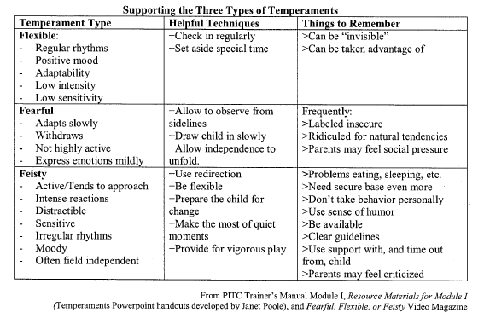
- Reflect on the experience.

Overall, how many stars would you give this experience? Explain your answer.

What is your biggest lesson learned?

How has this experience impacted your role as a future professional working with children?

