DATE: January 5, 2015

TO: Business Communications Students

FROM: Karen Lamoreux kfl

SUBJECT: INITIAL SELF-ASSESSMENT MEMO INSTRUCTIONS

Write a one-page (no longer), TRUE single-spacing (0 before, 0 after, and single-see page 3 for details), 10-12 pt. easily readable font (Arial, Calibri) Initial Self-Assessment Memo to me. The memo should describe your assessment of your current communication skill level, areas that you would like to improve, and course components (text, assignments, Lamoreux Laws, and report topic) that you think might contribute to your improvement goals.

GENERAL FORMATTING:
- Manually set up the memo format, left-aligned Business Block Style. See above formatting and page 4: How to Format a Memo. DON'T use a "memo template" from WORD or other program. Follow the Memorandum format example in this Packet and on textbook page 212. Also see page 211, Professional E-mail and Memos Checklist, and view the Preparing for Assignments PowerPoint in Week 02 Module.
- As with all business messages, your ISAM must have introduction, body, and closing sections.
- In the body, you MUST use a numbered list that matches (“mirrors”) the requested numbered items. Business messages often use lists to organize information because they save time for busy readers! Introduce your numbered list with an Independent Clause, followed by a colon. Review Colon Use information in the Spelling & Grammar Review Packet and Grammar Foundation PowerPoint in Week 02 Module and in the textbook Appendix A, Guides 27-30.
- Don’t include the questions; just answer the questions in complete sentences in your list.
- If your memo is shorter than ¾ page, you missed something! If it's longer than 1 page, you MUST cut the fat and filler! Trust me: hundreds of students before you were able to keep this to one page effectively, and you can, too.

PREWRITING PHASE:
- Complete Chapter 1's Activity 1.3 (textbook, pages 32-33): "Communication Skills Assessment: How Do You Stack Up?" Total your scores and read the interpretation (page 33). (See Week 02 Page/Module for ISAM materials.)
- Re-read the Syllabus, including the Puget Sound Employers’ Quote (Week 00 and 01 Pages/Modules)
- Read the Lamoreux's Laws: Advice/Tips for Student Success Packet (Week 02 Page/Module).

WRITING:

INTRODUCTION: Begin with an "authorization" (reminds the reader that he/she requested this memo). Continue that introductory sentence with a short description of what the memo will describe or cover.
HUGE TIME-SAVING HINT: See how I phrased the introductory sentence/paragraph of these Assignment Instructions above!

MORE ON PAGE TWO!!

BODY: Use complete sentences and list, number, answer, and address ALL seven (7) items below in the same order as they are listed:

- In what skill and trait areas did you score highest and lowest on textbook Activity 1.3? Describe.
- (a) How do you think your family, friends, past or present co-workers, and supervisor(s) would rate your skill and trait areas? (b) Why would they rate them this way?
- (a) Which of these skills and traits do you think are important for an employee to possess in your particular current or future career area? (b) WHY are these important for your field?
- (a) Are you satisfied with your present level of these communication skills? (b) Explain why or why not? (c) What steps could you take to become even better, even if you are already highly skilled? Note: Avoid the tired old cliché “There is always room for improvement.” Not only is it a cliché, but uses the weak filler word “there.” All of us can improve in some area, but use something more original, such as, “I could improve my _____ skills” or “could further develop my ____ skills” or “could be better at ____.” Also do not use the old-fashioned, “better myself.” Use “improve,” instead. (See Grammar Review Packet in Week 02 Module.)
- Re-read the Syllabus (Course description, Course Level Learning Outcomes, Requirements, Assignments, Employer’s quote, etc.) and textbook's Table of Contents. (a) Which class components and text Chapters do you think can help you to improve the skills/traits mentioned above, to increase your "marketability" or success even more in your current or future field? (b) How? (Note: Skip Chapters 15 or 16; our class does not cover these.)
- Pick ONE of the Lamoreux's Laws that you could use to help develop one or more of these skills/traits. Name and describe (a) which tip (not just the number) and (b) how it could help you develop the skill(s)/trait(s).
- What is your TENTATIVE report topic idea for your short written and oral reports? (See Discussion Forum 1 and Past Student Report Topic Examples) An answer to this is required. It’s fine if you change your mind later.

CLOSING: Finish your one-page memo with an appropriate and courteous "goodwill, forward-looking closing.” Don’t end abruptly. A forward-looking closing is literally, "I look forward to _______…" Then continue that sentence or short paragraph by describing something you look forward to in regard to the class and your skill development. (Use “something” besides “getting the credit, getting it over with, or getting a good score on my ISAM.” Those would not be good “reader benefit” or goodwill--or score helpers. ;) )

TONE: Be sure to maintain a civil, positive, pleasant, polite, and professional tone throughout your memo, as business professionals do.

I look forward to receiving and reading your ISAM!

OTHER ISAM DETAILS

REVISING:
- Before, during, and after writing, use the Professional E-mail and Memos Checklist on page 211 AND the specific-to-ISAM Checklist in this Assignment Packet.
- Use all that you read about Clear Writing Techniques from Chapters 4, 5, and 6, including conciseness, completeness, clarity, correctness, appropriate and courteous tone.
- WARNING: Proper formatting counts, as it demonstrates professionalism. See page 3 for How to Format a Memo.

SUBMIT IN ALL “3 WAYS OF SUBMISSION”:

Submitting in all 3 ways by due date is required. See customized Course Calendar for deadline.
(1) Canvas Assignment Submit to instructor through the Assignment Link AND
(2) Email to klamor@edcc.edu as attachment AND
(3) Into the SAME email, PASTE the text into the body

*Quick Guide to True Single Spacing in WORD 2007 and Beyond Documents:

*True Single-spacing: Default spacing was single (only 1 space between lines) through Word 97-2003, but changed to 1.15 spaces in between lines in and after Word 2007. This reduces how much you can fit on a page! You must use TRUE single spacing (with 0 before, 0 after, and “single setting”) for ALL BSTEC 110 documents. See below to learn how to change to single-spacing temporarily or as your Default (or ask an EdCC lab assistant for help, or Google some videos). True single-spacing helps you keep your memos and letters to the typical one-page length!) Warning: Do NOT simply choose “No Spacing” in the Styles bar; that is NOT the same. Don’t assume you know how to do this: read the instructions, and avoid losing points.

- “Select all” (Drag Cursor or use CTRL-A) of your page contents.
- In HOME tab view, find the Paragraph Section on the ribbon (has bullets/numbering, alignment, etc.). Look for the little arrow at the bottom of that section, to the right of the word “Paragraph.”
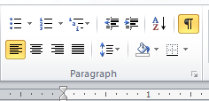
- Click the little arrow next to the word “Paragraph” to open up a dialogue box.
- Set Spacing to “Before” at “0 pt.” and “After” at “0 pt.” (But you’re not done yet!)
- ALSO, to the right, click the drop-down box to select “Single” for “Line Spacing.” You MUST COMPLETE this step, or you will not achieve true single spacing.
- Click “OKAY” to make this a temporary change for JUST this document (recommended), or click “SET AS DEFAULT” to have ALL of your future WORD documents set in single-spacing automatically.
- Put back in any missing paragraph breaks, since one blank line should be between paragraphs, unless they are part of a numbered or bulleted list.
- Below is what true single spacing settings look like:

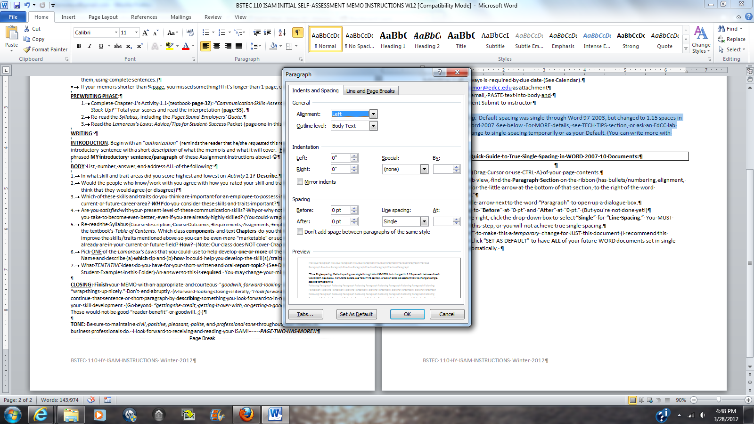
Remember: Set Spacing to 0 before and 0 after, and set Line Spacing to Single!

HOW TO FORMAT A MEMO-(targeted to the ISAM Assignment)

Use MEMORANDUM heading for your ISAM-DON’T use Assignment name as a heading. No letterhead address needed.

ALIGN TEXT LEFT Use an easily readable font like Arial or Calibri, 10-12 pt.

LEAVE ABOUT (can be “played with”) A 2-INCH TOP MARGIN FROM VERY TOP OF “SHEET” BEFORE TYPING THE “DATE”
CAPITALIZE "DATE, TO, FROM, SUBJECT" LEAVE 1 BLANK LINE BETWEEN EACH.
BEGIN cue word content AT 1-INCH RULER MARK (Use Toolbar above)
DATE: Current month name, day (numeral), year (Example: May 5, 2014) NO ordinals, like 1st 2nd, 3rd, 4th and no /

TO: Name of Recipient (Your ISAM assignment is written to Karen Fischer Lamoreux)
LEAVE 1 BLANK LINE BETWEEN EACH
FROM: Your Full Name yfn Write your initials in lower or upper case at the end of this line, next to your name or--if used—your job title. Use a "Handwriting" font like Lucida Handwriting for electronic documents.
SUBJECT: IDENTIFY TOPIC IN ONE-LINE SUBJECT LINE CAPITALIZE ALL OR MAJOR WORDS IN SUBJECT LINE
LEAVE 2 BLANK LINES BETWEEN MEMO SUBJECT LINE AND FIRST SENTENCE
LEAVE 2 BLANK LINES BETWEEN MEMO SUBJECT LINE AND FIRST SENTENCE
This memo explains how to format and compose a memo, which is a document form, more formal than e-mail, used for communication within an organization. (Letters are used to communicate outside the organization.)
LEAVE 1 BLANK LINE BETWEEN PARAGRAPHS
- NEVER use a SALUTATION ("Dear so-and-so") in a MEMO. Letters use that. Don’t create the mutant “LEMO.” ;) You MAY, however, use the person's name as part of the first (Introductory) sentence.
- In a ROUTINE REPLY memo (like the ISAM), include an "authorization" (As you requested, Karen) in Intro. An authorization reminds the reader that he or she requested the memo. Your introductory sentence "announces" what you’ll cover in the memo. (Example: " As you requested, Karen, here is my ISAM, which will describe …" or "As we discussed, Ms. Lamoreux, here is my ISAM, where I will describe …)
- Use left-aligned Business Block style for paragraphs. DON'T indent at the beginning of a simple paragraph (unless it’s a bulleted or numbered list, of course!) NEVER use “Justify” settings.
- Use the default setting for left and right Margins (1" to 1.25"). (See page 212 in Guffey book.)
- Use TRUE single-space* formatting within paragraphs (see first paragraph and below paragraph).
- Leave one blank line between paragraphs (hit "enter" to create a “hard break” and click the ¶ button on your ribbon to see the paragraph breaks).
LEAVE 1 BLANK-LINE BETWEEN PARAGRAPHS
The closing paragraph should have a "forward-looking close” (something class-related that you are looking forward to besides your grade, the credit, or getting it over with!) ;) DON'T use a COMPLIMENTARY CLOSE (no "Sincerely") or a SIGNATURE BLOCK (letters, not memos, use those). Your initials by your name (above) are your "signature" in a memo!
LEAVE 1 BLANK-LINE BETWEEN PARAGRAPHS
I look forward to reading your memo! (Notice this "forward-looking closing!” )
Leave 1-3-lines-depending upon balance- under last paragraph.
Do NOT use a complimentary close or Signature block-those are for letters, not memos!

BELOW IS A "NOTATIONS AREA,“ if used. Your ISAM will NOT have these, but you should be aware of them.
YN:dpl Typist’s initials are used ONLY if the memo was written by one person (initials-in this case, YN) and then keyed/typed by another (in this case, dpl).
USUALLY LEAVE 1 BLANK LINE BETWEEN NOTATIONS
Attachments (2) Enclosures/Attachments notification. Attachment means stapled to the memo. Enclosure is loose, added to the envelope. It's unusual to put a memo in an envelope, but it happens. ONE enclosure does not require a number.
USUALLY LEAVE 1 BLANK LINE BETWEEN NOTATIONS
cc: S. Smith, Vice-President
J. Johan, Manager ONLY if copies given to others BESIDES reader. May also spell out full name; include position title or omit.

See page 2’s “Quick” Guide to single-spacing, or ask an EdCC lab assistant about how to change to single-spacing temporarily or as your Default. (You can write more with single-spacing!)
INITIAL SELF-ASSESSMENT MEMO (ISAM) CHECKLIST

Review this Checklist before, during, and after writing your ISAM to save valuable revision time and points.
If you can't “check it off,” FIX the problem to earn points and professional expertise.
Note: This Checklist is quite thorough, but read and follow the Assignment Instructions carefully, too!

FORMATTING-HEADING
Studied formatting examples on page 212 in textbook and Example in ISAM Instructions.
Keyed in MEMORANDUM about 1.5 inches from top, or used blank heading.
Did NOT use the name of the Assignment as a Heading at the top.
Manually formatted "cue word headings" in THIS order: DATE, TO, FROM, SUBJECT, in CAPS, left aligned. (DON’T use a WORD MEMO TEMPLATE!) Begin “cue words” about 2 blank lines below Memorandum heading.
Left ONE blank line (called "double spacing") between the above CUE WORD lines
Placed the date, Karen Lamoreux's name, your name, and Subject line at the 1" tab ruler mark (see toolbar)
Spelled out the month, numeral for day, numerals for year. Did NOT use ordinals: 1st, 2nd, 3rd, 4th, etc. for dates and used US style (starts with and spells out month), not European or military style (starts with day)
Spelled recipient's name correctly (Karen Lamoreux, in this case!)
Used a "handwriting-type font" to put your initials next to your name and, if used, job title, which serves as a "signature" on a Memo. Upper or lower case. (On hard-copy Memo, you would initial by hand, of course.)
Used a one-line SUBJECT LINE that "headlines" what the document is and what it contains. CAPITALIZED (permissible to capitalize first letter of each major word, if you know how, but "110 Company" suggests all CAPS).
Left TWO blank lines (called "triple spacing") between Subject Line and the first sentence.
OPENING/INTRODUCTION
Began with an "authorization" in conversational tone ("As you requested, Ms. Lamoreux,"). Did NOT use trite business phrases like "As per your request, pursuant to your request," etc. Eeek!) (See pages 178 and 184)
Continued that SAME sentence with a descriptive introduction of what this document is, and what it will include (for example, "…here is my ISAM, which will describe ___________________…")
After the brief introductory sentence or short paragraph, began a new paragraph for Body (leave one blank line in between paragraphs). NUMBERED and LISTED answers correspond to questions (see below).
Used “single spacing" within paragraphs, but left ONE blank line between paragraphs
BODY
Body provides what was promised in the introduction/opening, and in the order it was promised.
As instructed, used a numbered LIST to provide the information requested in the seven items (this one-page Memo is too short to effectively use more than one list), introduced with a properly used colon. Did NOT include the questions, just answers. Did NOT use the clichés, “There is always room for improvement” or “better myself.”
Addressed all items thoroughly, yet concisely, using Clear Writing techniques described in Chapters 4, 5, and 6 (for example, avoided "fat" and unnecessary "filler") and kept Memo to ONE page maximum length.
CLOSING
Used a sentence or short paragraph that "wraps up" the Memo courteously, including a sincere "forward-looking close" ("I look forward to…") related to the topic of the Memo and/or class.
Capitalized all words that should be capitalized. (Did not use "text messaging" abbreviations or lack of capitalization. Capitalized "I" for personal first-person pronoun. Spelled out "want to," not "wanna," etc.) Definitely capitalized the word English or other language names, if used!
OTHER
Maintained positive, pleasant, professional "tone" throughout. This does not mean "dry and dull," or lacking wit and gentle humor, but it does mean business-like (no negativity, insult, rudeness, complaining, incivility, or sarcasm).
Did NOT use a signature block at the end (because it is a memo, not a letter). Did not create a “LEMO!”
Ran Spellcheck. Read out loud to catch errors or odd phrasing. Had someone listen and proofread.
Checked grammar and punctuation. Passed CCCCCAT Scan: Clear, Concise, Complete, Courteous, Correct Appearance and format, appropriate Tone.
Used TRUE SINGLE-SPACING (see page 3) with Spacing of 0 pt. before, 0 pt. after, and “single” Line Spacing.
©2000 kfl rev. 2001-2015

